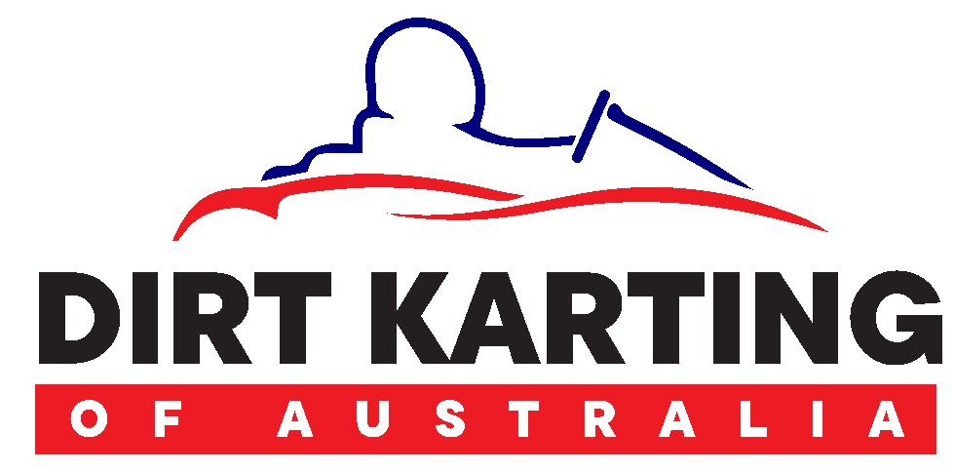
MEDICAL CLEARANCE FORM

If you have answered “yes” to any of the following questions 1-11 on the online Dirt Karting of Australia licence application, and you are applying for a licence to drive a go-kart you are required to have your doctor complete the medical clearance below.

If your licence application requires a medical clearance, it will not be processed until that clearance is received.

None of these items will necessarily preclude you from holding a licence, but it is a safety and Insurance requirement that the information above is disclosed.

Once this form is completed, please email it to secretary@aidka.com.au.

Dirt Karting of Australia Medical Declaration
Statement by Applicant (Name): ___________________________________________ | Yes | No
- Have you even been declined Life Insurance on medical grounds?
- Are you required to take a state roads or traffic authority medical examination to obtain a motor vehicle licence?
HAVE YOU EVER SUFFERED, BEEN DIAGNOSED OR HAD TREATMENT FOR: -
- Any medical or surgical conditions that could interfere with the fine movements of your arms and legs?
- A psychiatric or psychological Illness?
- Persistent or severe headache, head injury, epilepsy, seizure, fainting or giddiness?
- Heart or lung disease, blood vessel disease, hypertension, coronary bypass or other major surgical procedures?
- Cancer, kidney, bladder, diabetes, gastrointestinal, thyroid or blood disorders including any surgical procedure?
- A significant illness, injury or surgery not listed?
- Any ear disorder that may affect your balance including tinnitus?
- Eyesight impaired for distance vision to such an extent that it cannot be corrected?
- Are you taking any injections, tablets or other forms of medication?
- Are you required to wear spectacles to correct distance vision?
- Are you on Workcover/Workers Compensation? (If YES, drivers are not permitted to race)

Declaration
- I certify that the statements made to Dirt Karting of Australia regarding my physiological and physical condition and any previous illness are true and correct.

- I declare that should any of the above conditions become evident during the currency of this licence, I agree to abstain from exercising the privileges, will notify Dirt Karting of Australia and submit to a further medical examination the results of which are to be forwarded to the Dirt Karting of Australia Secretary secretary@aidka.com.au

- I undertake not to use medication or drugs that might be considered illegal within a period of 24hrs prior to a race competition or any participation of any sort.
Applicant Signature: Date: ____________________

An Applicant making a false declaration is liable to refusal/cancellation of their Dirt Karting of Australia Licence.

Medical clearance to race a Gokart (to be completed by your Dr/Physician ONLY if required) See above:
Doctor/Physician Name:

Doctor/Physician
Address:
Phone #
AND
Doctor/Physician stamp

Having examined:
(Applicants name)

who I understand is applying for a Dirt Karting of Australia Licence to race a Gokart. In my medical opinion, there are no medical conditions that would affect his/her ability to control/drive a Gokart.

Any further comments? ____________________________________________________________________________________________

____________________________________________________________________________________________

____________________________________________________________________________________________

Doctor/Physician
Signature/Date

