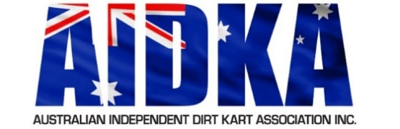**AIDKA Sub Committee**

**Application/Nomination Form**

The Australian Independent Dirt Kart Association Inc. (AIDKA) Board is responsible for the strategic leadership, direction and development of the sport. The AIDKA Board delegates some of its power and authority to Sub Committees and must be aligned with the strategic direction and purpose of AIDKA.

Candidates wishing to apply as a Sub Committee Member of AIDKA should note the eligibility requirements and criteria set out in the AIDKA Charter and Position Descriptions relevant to this position.

Typed applications for Sub Committees (submitted by e-mail) should include:

**• A completed Sub Committee Application Form**

|  |  |  |  |
| --- | --- | --- | --- |
| **Sub Committee** |  | | |
| **Nominee’s name** |  | | |
| **Email Address** |  | **Telephone** |  |
| **Nominee’s Signature** |  | **Date** |  |
| **Nominated By** | *Name of AIDKA Member* | **Lic. No.** |  |
| **Seconded By** | *Name of AIDKA Member* | **Lic. No.** |  |

I hereby declare my consent for my interest to be recorded and communicated to all relevant persons within AIDKA.

|  |  |  |  |
| --- | --- | --- | --- |
| **Signature** |  | **Date** |  |

|  |
| --- |
| **NOMINATION/APPLICATION FORM** |
| Nominee Statement: *Reason and motivation for your interest in being a part of the nominated Sub Committee (**issues or opportunities you may hope to address through your involvement)* |
|  |
| Specifically address how you can assist and improve AIDKA within the roles and responsibilities outlined in the AIDKA Position Description for this position. |
|  |
| Involvement in Sports Industry (any sports) |
|  |
| Involvement in AIDKA (incl. Board, Committee and Club Level experience) |
|  |
| Experience directly related to this position |
|  |
| General Experience |
|  |
| Qualifications |
|  |

All applications must be submitted in writing to AIDKA Secretary via [secretary@aidka.com.au](mailto:secretary@aidka.com.au) and received by 5pm (ACDT) Wednesday 8th January 2025.