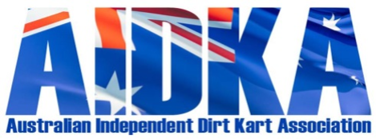
ABN 58 243 272 143
Expenses Claim Form

Claimant Name _____________________________________________________________
Event _____________________________________________________________________

Date Of Expense | Description of Expense | GST Portion | Tax Invoice
Total Amount to be Reimbursed |  |  | $
Please provide your Account Details:
BSB ___________________________ Account Number ____________________________________
Account Name _____________________________________________________________________
Claimant Signature _______________________________________ Dated _____________________

Claimant Position at Event ____________________________________________________________

AIDKA REIMBURSEMENT RATES
AIDKA OFFICIALS AT TITLE EVENTS
- Airfares, accommodation, hire cars, will be purchased by AIDKA
- Mileage rate $0.30 per kilometre
- Meal allowance $30.00 per day
- Accommodation allowance if not staying in AIDKA provided accommodation or shared accommodation with non AIDKA officials of up to $65.00 per day. Accommodation expense claims to be paid upon copy of receipt provided to AIDKA Treasurer.
- Airport Parking (if required)
DELEGATES FOR MEETNGS
- Face to Face Council/AGM meetings will be held in South Australia to limit expense to association. Majority of clubs are based in South Australia.
- Interstate delegates are only eligible to have airfares for from last destination to Adelaide
- WA clubs from Perth
- Alice Springs from Alice Springs
- Top End from Darwin
- Weipa from either Cairns of Brisbane
- All other costs to interstate delegates are the responsibility of the Club they are representing (e.g. Fuel, accommodation, hire cars, meals etc.)
- South Australian Delegates are only eligible to have mileage rate paid at $0.30 per kilometre rate.
- All other costs to South Australian delegates are the responsibility of the Club they are representing (e.g. accommodation, etc.)
CLAIMS PROCEDURE
- The claim form may only be completed and supplied to AIDKA by the claimant directly.
- The Claim form must be supplied with receipts.
- The claim for must be submitted within 30 days of the event/meeting date.
- All claim forms if not in person are to be sent via email to treasurer@aidka.com.au

All rates will be reviewed annually and approved at the AGM.

