FORM 3 – ACCIDENT REPORT FORM
PLEASE USE ONE FORM PER DRIVER
Please consult Driver if possible

CHIEF STEWARD | LIC. NO. | CLUB | DATE
 |  | YORKE PENINSULA
TIME: AM PM DAY NIGHT

CLASS | KART NO. | DRIVER NAME | LIC. NO.
DETAILS OF INCIDENT
CHIEF STEWARDS SIGNATURE
KART CONTACT TYPE
(Please tick any appropriate)
ROLL OVER
SINGLE KART
WHEEL TO WHEEL
T-BONE
SIDE TO SIDE
FRONT TO REAR
RACE CONDITIONS AT INCIDENT
(Please tick any appropriate)
WET
GOOD TO FAIR
DRY TO DUSTY
ROUGH OR RUTTED
BLACK

NATURE OF INJURY (EG Ribs, Arm, Foot etc.) | MEDICAL ATTENDEE | CLEARANCE | TIME CLEARED
 |  | CLEARED NOT CLEARED
DIRECTION OF RACING | LAP NO. | NO. of KARTS INVOLVED | NO OF KARTS IN RACE
CLOCKWISE ANTI-CLOCKWISE
CONTRIBUTING FACTORS OF INCIDENT (Please tick any appropriate)
WET SECTION OF TRACK  DRY SECTION OF TRACK  ROUGH TRACK  CONTACT OUTSIDE BARRIER/FENCE | CONTACT WINDROW  SAND TRAP/RUN OFF AREA  SUN/POOR VISION  POOR LIGHTING | LIMITED PASSING OPPORTUNITIES  DRIVER ERROR  DRIVER EDUCATION  PENALTY GIVEN
MAP OF WHERE THE ACCIDENT/INCIDENT OCCURRED ON THE TRACK
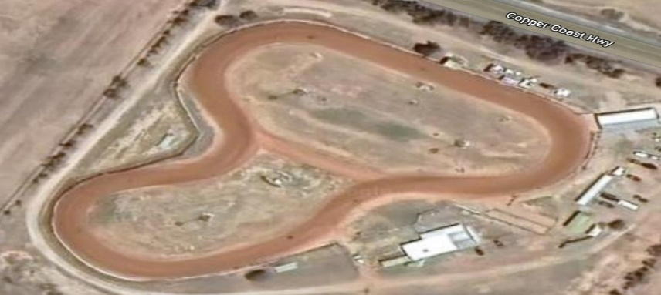
USE THIS STAR TO INDICATE POSITION FOR ELECTRONIC ENTRY
NOTE: If submitting electronically this form must be retained by the club for a minimum of 7 years.

