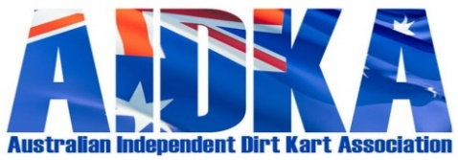

FORM 2 – STEWARD RACE PENALTY CHARGE FORM - 2024

Chief Steward name:
Driver’s name: |  |  | AIDKA Licence #
Heat:  Class:  Kart No:  Time of Incident: | Description of Offence:
 | Penalty Recorded in Logbook: |  |  | Yes |  | No
 | Time Driver Informed of Penalty imposed:
Rule No: | Protest Lodged: |  |  | Yes |  | No
 | Appeal Lodged: |  |  | Yes |  | No
Penalty Imposed:

Penalty dates: ____/____/____ to ____/____/____
Drivers Signature:

Drivers Representative Signature:

Chief Steward Name & Signature:
AIDKA Lic #
Date:
January 2024

