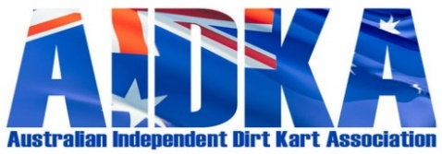

FORM 1 - CHIEF STEWARD REPORT – 2024

Name of Club: ______________________________________________ Date: ________________________
It is mandatory that this report is completed by the Chief Steward.
Fri Sat Sun
Start Time:
Finish Time:
No. of Karts nominated:

Was event run under lights? YES / NO
Was St John First Aid in attendance? YES / NO
First Aid Names: ________________________________________
Weather Conditions: Hot / Cold / Wet / Windy Comments:

Track Conditions: Wet/Rough/Fair/Good Comments:

POSITION: | NAME: |  | AIDKA LICENCE #
Chief Steward
Assistant Chief Steward
Steward No. 1
Steward No. 2
Steward No. 3
Steward No. 4
Steward No. 5
Scrutineer No.1
Scrutineer No.2
Scrutineer No.3
Starter
Out Grid
In Grid
Scales & Fuel Tester
Drivers Representative 1
Drivers Representative 2
Drivers Representative 3
How many Penalties or Written Warnings were handed down? |  | Penalties
 |  | Written Warnings
Were any Accident / Incident Forms filled out? YES / NO If YES how many?

Were there any Protests or Appeals lodged on the day? YES / NO
- Drivers with a Probationary Licence or having Licence Endorsement must have their log book filled out in the appropriate section of the log book and be signed by the Chief Steward of the day.
- All Penalties from B – G shall be recorded in the drivers log book as per Appendix “C” and recorded on the Penalty Charge Form(Form 2) and forwarded with this report to the AIDKA Secretary within two days of completion of the race meeting.
- All red light incidents and/or suspected injuries (on or off track) shall be recorded on an Incident Report Form (Form 3) and forwarded with this report to the AIDKA Secretary within two days of completion of the race meeting.
Chief Steward Signature:

