**Accommodation at Wagin RV Area**

**2022 WA State Titles**

[](http://www.google.com.au/url?sa=i&rct=j&q=&esrc=s&source=images&cd=&cad=rja&uact=8&ved=0ahUKEwim6rPrnbjZAhUKybwKHYtVCJoQjRwIBw&url=http://mrburdess.global2.vic.edu.au/2017/06/18/bowens-fantastic-trip/&psig=AOvVaw0ADF41oSxUrk8yTFEqoVaA&ust=1519344551877467)

[](https://www.google.com.au/url?sa=i&rct=j&q=&esrc=s&source=images&cd=&cad=rja&uact=8&ved=0ahUKEwj9rvb5m7jZAhVE2LwKHcVRDusQjRwIBw&url=https://www.greatsouthernkart.club/nominations&psig=AOvVaw3SKEisOY37wNY6hSD4nzHQ&ust=1519344088852675)

**About Wagin**

Wagin (meaning the Emu’s Watering Place) is located 228 kilometers south east of Perth in the heart of Western Australia’s Great Southern Region. The population of the Shire is approximately 1900 and the Shire comprises an area of 1950 square kilometers.  The economy of the district is based on agriculture with wheat, barley, oats, canola, and lupins being the main crops and sheep and cattle production being prominent.  The local industries and services are based around the agricultural sector.

[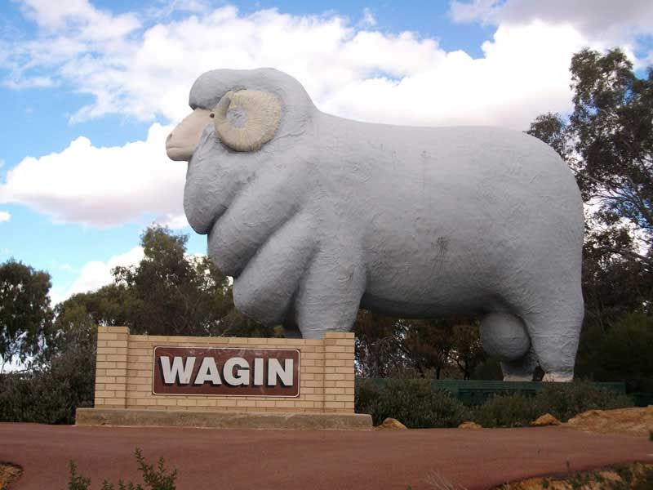](http://www.google.com.au/url?sa=i&rct=j&q=&esrc=s&source=images&cd=&cad=rja&uact=8&ved=0ahUKEwjSzdq-qLjZAhVT57wKHVy8C20QjRwIBw&url=http://www.australiaforeveryone.com.au/wa/wagin.htm&psig=AOvVaw0ngEPhI7FmyYtT-rcyHGYv&ust=1519347433531003)

[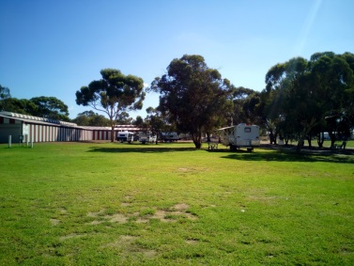](https://www.google.com.au/url?sa=i&rct=j&q=&esrc=s&source=images&cd=&cad=rja&uact=8&ved=0ahUKEwjt4_qvxbjZAhXCyrwKHTxRD-kQjRwIBw&url=https://www.fulltimecaravanning.com.au/wagin-showgrounds/&psig=AOvVaw2VsJ-WaHX5uMXZLzHMaswY&ust=1519355193644745)[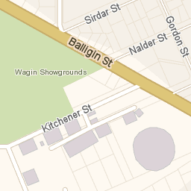](https://www.google.com.au/url?sa=i&rct=j&q=&esrc=s&source=images&cd=&cad=rja&uact=8&ved=0ahUKEwjIku6AxbjZAhUEx7wKHfopBQ8QjRwIBw&url=https://www.yellowpages.com.au/wa/wagin/ranbuild-12577742-listing.html&psig=AOvVaw0JtFQuJRwi11zKnVm5pgih&ust=1519355100909738)

**Accommodation**

As there is no camping at the track during both the States Titles, the Great Southern Kart Club has secured exclusive use of the Shire of Wagin RV Park for the entirety of the WA State Titles. That’s right you can book accommodation directly through Great Southern Kart Club for your entire stay.

The RV Park is located at the Wagin showgrounds on Ballagin St Wagin. This is less than 5kms from the track and is an easy 20-minute walk from the track or 2 minute drive. The RV area is housed within the showgrounds with all sites being powered with a mix of 10 and 15 amp connections. There is a very well-maintained shower and toilet block for your use too. We will run a limited bus service from the RV Area to the track.

The RV Park is full of green grass and well shaded with trees. Whilst camping at the RV Park you have access to a skate Park, Playground and plenty of space for the kids to run around.

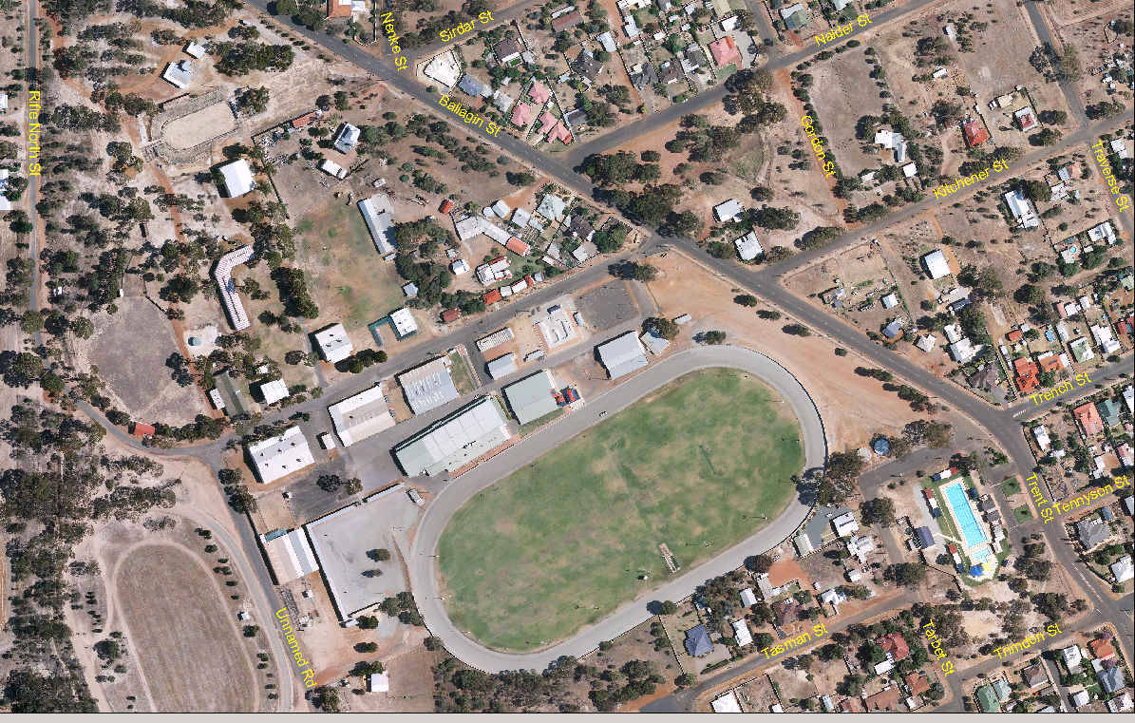

Accommodation Availability / Costing

* ***State Titles Weekend*** – Thursday September 1 until Monday September 5 (4 nights). Cost per site (1 Caravan / Trailer etc only) $20 per van per night, and use of all facilities available to Great Southern Kart Club at the RV Centre.

**In order to secure your booking the attached booking form must be filled out and payment in full must be received by **15th August 2022.**

All payments to GSKC

BSB: 036 153 Acc: 136982

Please use your surname/number of nights when making the deposit

***ACCOMMODATION BOOKING FORM 2022***

Wagin Shire has provided the RV area at the showgrounds to Great Southern Kart Club to use for Titles camping. There is a playground area, skate park, ablution block and is walking distance to town. Your booking will be accepted only when payment in full is received.

Surname: Given Name:

Mobile: Email:

ADDRESS:

Arrival Date: Departure Date:

SIZE OF TRAILER/CARAVAN: (9mx6m bay allowance)

Adults: Children:

**Please select your duration of stay**

* 1 night $20
* 2 nights $40
* 3 nights $60
* 4 nights $80

Payment must be by 15th August 2022.

Please email your form to: [titles@greatsouthernkart.club](mailto:titles@greatsouthernkart.club) and make payment to

Great Southern Kart Club

BSB: 036153

ACC NO: 136982

REF: Surname/number of nights **cid:image003.jpg@01C99695.55F19900**Payment Receipt No: __________

**cid:image003.jpg@01C99695.55F19900**