At the November AIDKA council meeting the Club’s Voted 10:3 to allow the introduction of the alternative X30 components from February 2020

AIDKA conducted both Dyno and Track Testing on these components and presented this information to the council before the clubs made their decision.

Testing was conducted by two drivers at two different tracks. Similar findings were found by both drivers. The first test was performed in race conditions while the second test was a one on one test, new vs old components.
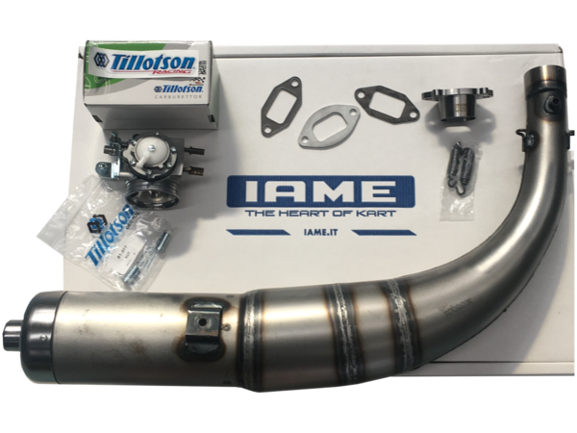
TEST RESULTS

The results can be summarized as follows:

Tillotson HW-27A carby with larger reed block (29mm instead of 28mm) felt strong but in comparison to the old Tryton carby, lacked bottom end power.

The New Style Pipe gave us the reverse result with increased bottom end power out of the tight corners of the track. Without changing anything like gearing, it still maintained similar mid-range and bottom end power compared to the old pipe.

The PVL ignition provided no difference in performance.

When both the Tillotson HW-27A carby and New style muffler were used together there was negligible difference between the new pipe/carby and the old pipe carby combination. For this reason, it was proposed that either new or old pipe/carby combinations could be used, but not a combination of the two.

Dyno testing did show an increase in power in the lower power range but it has not shown on the track. This may be put down to dirt karts not using the lower end power range as offer as bitumen karts do.

THE NEW RULE FOR 2020

The clubs voted to allow the following:
Either combinations of the following carby & pipe
Tryton Carby & 2017 Header pipe/ Exhaust combination or
Tillotson HW-27A carby & one-piece exhaust
Either ignition can be used with each carby/pipe combination
The use of the new wider radiator is also allowed to be used with any of the AIDKA approved engines

WHY THE CHANGE

This change was due to IAME changing the components available on new engines. Karting Australia introduced the carby and pipe at the beginning of 2018 and the ignition at the start of 2019. IAME no longer purchase from Tryton and stocks of new IAME/Tryton carby are no longer available in Australia. It is expected that very soon current ignitions and mufflers are either going to become a lot more expensive or no longer available as AIDKA are one of the last to only use this combination in the world.

THE COST

AIDKA and the IAME importer have negotiated a discounted offer for all current AIDKA X30 Owners.
By suppling their engine number to an IAME dealer, they will be eligible for the below kit

AIDKA 2020 kit $595.00

The kit includes Tillotson HW-27A carby, carby gaskets, mounting nuts, inlet manifold & studs, Muffler, Manifold, Exhaust springs, Exhaust gaskets, Spacers & Studs.
Below are the components and costing if purchased individually at the AIDKA intro pricing.

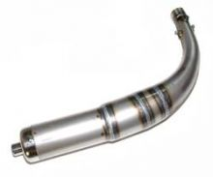
2020 Pipe Kit $365.00 includes pipe, exhaust manifold, gasket and springs

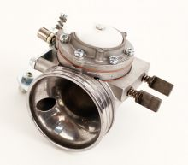
Tillotson HW-27A carby $225.00 intro price (50% discount will be offered to AIDKA drivers)
The Reed block inlet is $50.00 at the intro price or we would allow the old one to be machined to the new size

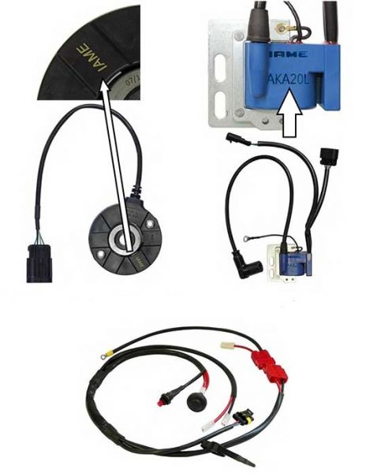

The PVL Ignition kit is $749.00. It is a completely different system but is more basic in components. It eliminates the green box, relay, key etc. and is replaced with just a start and stop button

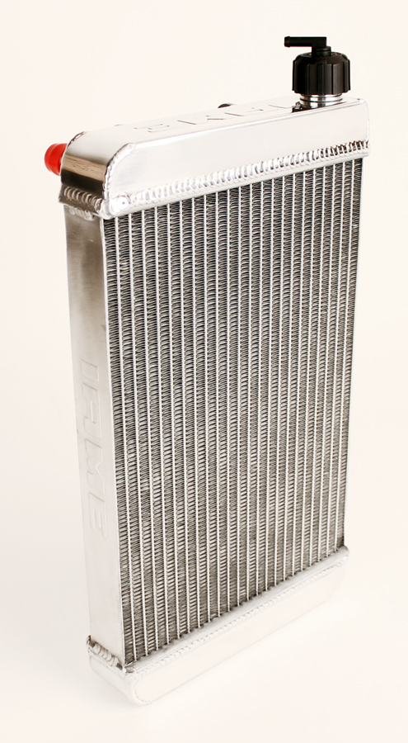

The radiator will also change on new specification engines supplied. To change the Radiator, it will cost $395.00 plus $116.00 for the mount. It is the same height, but 35mm wider and slightly thicker.

CONCLUSION

From testing, it has shown that the alternative components provide no real difference on the track to the old components. The core engine is still the same, with only the carby, exhaust, muffler and radiator being the only changes. It is hoped that the parity between the older generation engines is maintained, not forcing drivers to purchase new motors to stay competitive.

